**Issue Statement**

Strengthening targeted government interventions to make it more effective at targeting child malnutrition.

**Background**

Child malnourishment is a problem that is affecting a significant portion of the population in the Global South. Malnutrition in childhood often manifests in symptoms such as children’s growth stunting and being underweight, where children are often too thin or too short for their age. Chronic child malnutrition impairs children’s development, resulting in lower cognitive capability and performance in schools and in the workplace. It also results in these children being more suspectable to diseases and they generally have higher mortality rates. Not only is child malnourishment detrimental to individual’s health, but it also results in a less productive and capable workforce and severe damage to human capital available to the society that could spur its economic and social development. It is also more costly for governments and households having to support less healthy individuals. Therefore combating child malnutrition is a top priority for developing countries in the Global South and for international health organizations such as the WHO.

The Brazilian government has successfully reduced child malnourishment in Brazil over the past 3 decades. It is an example of successful implementation of health and social policies that together helped to eradicate one of the greatest scourges to human health and economic development. Childhood malnutrition in Brazil fell from over 19% in 1989 down to 7% in 2007 (WFP, 2017). Access to healthcare and inequality in health outcomes has also been substantially improved (Victora et al., 2011). Since the Canadian foreign aid policy is dedicated to combating malnutrition, it is important to identify where resources can be most effectively spent and have the most impact on reducing child malnutrition. Using Brazil as a case study, we attempt to identify best practices using a linear regression on a selection of variables that in health literature have been identified as having an impact on child nutrition and health.

**Methodology**

The data for the analysis comes from the latest available Demographics and Health Survey (DHS) conducted in Brazil, which was in 1996. The variable used to approximate child malnutrition for this case study is the weight-to-height ratio measured in standard deviation from the reference mean. According to the WHO guidelines, child malnutrition is defined as when the z-score of the child’s weight-to-height ratio is less than -2 standard deviations from the reference mean. The WHO recommends the use of z-scores to measure child nutrition, because it is more accurate and can be applied to a broad spectrum of variables such as age, height, and weight. However, the weight-for-height ratio is not a perfect measure of child health, since many variables influence cognitive development and health may not manifest as height or weight gain. Furthermore, health conditions such as obesity are spreading in the Global South, making measurements such as weight-to-height ratios less indicative of nutrition status.

The independent variables chosen for the analysis are: months of breastfeeding, the years of education that mothers have received, the type of sanitation facility that the household has access to, the source of drinking water, and the settlement type. These variables are chosen due to their proven links to human health. The impacts of the variables are estimated using a linear regression. The results of the regression show that only the years of education received by mothers and access to sanitation facilities are statistically important factors contributing to childhood nutrition.

Although the substantive impact of these variables on the weight-for-height ratio of children is relatively modest but international aid should continue to be provided to improve both maternal education and sanitation facilities. This is because both education and sanitation facilities have spillover benefits beyond child malnutrition. A better-educated workforce contributes to building human capital that is important for economic growth, while sanitation facilities also limit the spread of infectious diseases that spread through sewage, such as cholera.

**Analysis of Results**

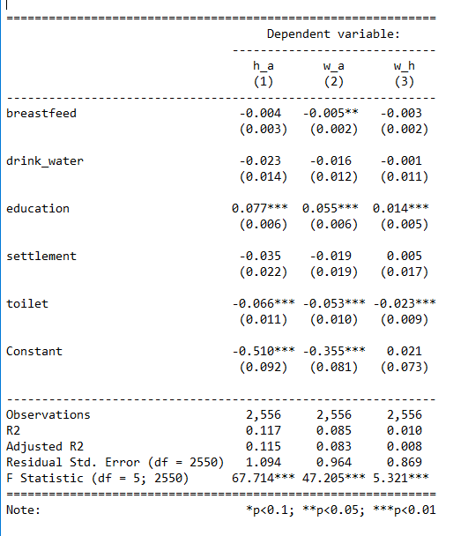The link between maternal education and children's health has been long established. Better educated mothers can access better career opportunities and are subsequently more likely to be able to afford nutritious food for their children. In addition, better-educated mothers are also better placed to receive nutritional guidelines and proper child-rearing techniques. Additional literature evidence from Brazil suggests that improvement in women’s access to education and school completion may account for as much as 40% of the decline in child mortality in the country (Monteiro, 2016). Investment in women’s education evidently yields a good return in the form of much lower rates of child malnutrition as well as other socioeconomic benefits that come from education.

The other significant factor that contributes to mitigating child malnutrition is access to quality sanitation facilities. Sanitation facilities are the crucial in preventing the spread of diseases that can seriously damage children’s health and ability to absorb nutrition. These health risks include the spread of parasitical worms, which is a major cause impaired development and health issues such as stunting in the Global South. Improving sanitation is, therefore, a preventive measure that can reduce morbidity and mortality and improve health and nutrition for the population in the long run. With Canada's official commitment to fulfilling the SDGs, investment in sanitation infrastructure will contribute greatly to building healthy and sustainable communities.

The remaining variables did not show statistical significance but are important for consideration. The quantitative evidence regarding the effects of breastfeeding on child malnutrition is surprising, as it showed no statistical significance. This is surprising because the WHO advises exclusive breastfeeding up to 6 months and complementary feeding up to 2 years (WHO, 2017). In many other countries, breastfeeding has been demonstrated as an effective way of improving child nutrition and health. In addition, the Brazilian government has set up “milk banks” where babies of mothers who are unable to breastfeed can be fed, and they are reported to be relatively successful ("How Brazil tackles the scourge of child malnutrition," 2013). Furthermore, unlike major infrastructure projects or provision of food, a health campaign promoting breastfeeding is conceivably cheaper by comparison. Although it might not be one of the priorities, encouraging breastfeeding should not be dismissed as a contributing factor.

The remaining variables, the type of settlement the respondent lives in, and the source of drinking water, are both statistically insignificant. The lack of statistical significance for settlement type is encouraging from an aid standpoint. Cities are often disproportionally benefactors of government policy due to their high population concentration and economic importance. Due to the economics of scale that cities enjoy, it is also much more economical to provide basic services. Urban-rural divides where urban residents enjoy a markedly better standard of living is a very real concern. In the case of Brazil, the lack of significance for the settlement type may be due to recent social programs implemented aimed at reducing social disparities and economic inequality (Monteiro, 2016). From the perspective of combating malnutrition, it means that the urban-rural divide is not an insurmountable divide, even in a country as economically divided and unequal as Brazil.

Drinking water is an important health concern, but it does not seem to have a direct impact on child nutrition status. While improving the safety of drinking water is important for general health, budgets for combating malnutrition can be better spent elsewhere.

**Recommendations**

* **Strengthen education for women.** Women’s education is evidently very important for the health of their children. Encouraging women to complete their primary and secondary education, and if possible, tertiary education will substantially improve child malnutrition. Programs aimed at keeping women in school can take on forms such as conditional subsidies for girls to continue to attend school and basic income programs that can alleviate the economic pressure on girls to drop out and start working. Integrating nutritional education into the curriculum to educate future parents on how to maintain their children’s health is another relatively inexpensive but effective strategy.
* **Improve Sanitation Facilities.** Sanitation facilities are very important for a number of reasons, not the least of which is disease prevention. International investment in sanitation infrastructure capacity includes connecting private homes and public facilities to the sewage systems when possible, building and maintaining public toilets, and in rural areas providing septic tanks. Building more and better sewage and waste processing plants to clean up the environment and handle the increased load is also a necessity. Since building sanitation infrastructure is expensive, careful budgeting is required. Educating the population on hygiene and health may be less expensive and complementary to infrastructure building, but cannot replace access to physical and well-maintained sanitation infrastructure.
* **Integrate socioeconomic data with maternal health data.** It has generally been shown that health outcomes are heavily tied to socioeconomic factors such as income, wealth, food security, access to healthcare, etc. The lack of these social and economic data on respondents in the 1996 DHS Survey impairs the range of analysis that can be carried out to determine the best forms of intervention. Collecting data on socioeconomic variables opens the possibilities on a wider range of interventions, including social interventions.

**Bibliography**

How Brazil tackles scourge of child malnutrition. (2013, June 8). *BBC News*. Retrieved from http://www.bbc.com/news/world-latin-america-22825246

Monteiro, C. (2016, September 7). What Brazil can teach the world about tackling child malnutrition. Retrieved July 20, 2017, from http://theconversation.com/what-brazil-can-teach-the-world-about-tackling-child-malnutrition-64652

Victora, C. G., Aquino, E. M., do Carmo Leal, M., Monteiro, C. A., Barros, F. C., & Szwarcwald, C. L. (2011). Maternal and child health in Brazil: progress and challenges. *The Lancet*, *377*(9780), 1863–1876. https://doi.org/10.1016/S0140-6736(11)60138-4

WFP. (2017). 10 Facts About Food and Nutrition in Brazil. Retrieved July 27, 2017, from https://www.wfp.org/stories/10-facts-about-food-and-nutrition-brazil

WHO. (2017). WHO | Breastfeeding [INGO]. Retrieved July 18, 2017, from http://www.who.int/topics/breastfeeding/en/